Universidad Politécnica Metropolitana de Hidalgo

Cervantes Zúñiga Alejandro Ezequiel

Engineering in Infomation Technologies

Cuatrimestre: 1 Group: A

Signature: Industry 4.0

Ing. Javier Elías Barrón López

Topic: First Code

January-April 2020

In my first code I am only declaring my variables and then I only print them.

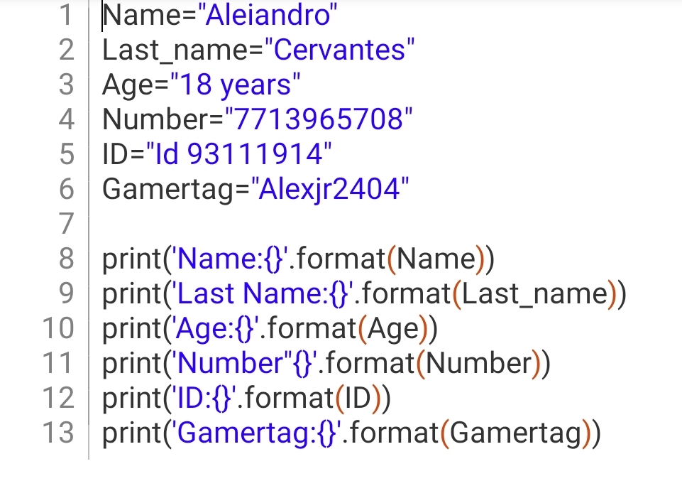

The main idea is to print a user card in order to have access to a video game store.